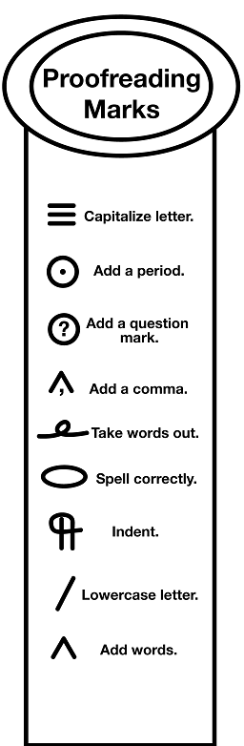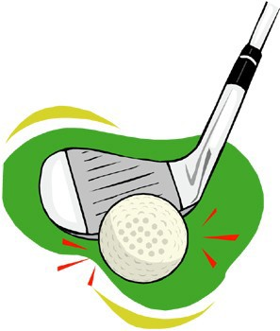
Name:

Editing: How many mistakes can you find?

Miniature Golf

Phil Matthew, and Andrew played miniature golf. On the first hole, Phil got a hole-in-one! At another hole, Matthew's Ball went into the water The best golfur of the day was Andrew who finished with a score of 28. Everyone had a grate time

Name:

Editing: How many mistakes can you find?

Miniature Golf

Phil Matthew, and Andrew played miniature golf. On the first hole, Phil got a hole-in-one! At another hole, Matthew's Ball went into the water The best golfur of the day was Andrew who finished with a score of 28. Everyone had a grate time
Answer Key: Corrections in Red

Name:
Editing: How many mistakes can you find?
Miniature Golf
(indent) Phil, Matthew, and Andrew played miniature golf. On the first hole, Phil got a hole-in-one! At another hole, Matthew's ball went into thewater. The best golfer of the day was Andrew who finished with a score of 28. Everyone had a great time!
Skills:
- indent
- commas in a list
- lower case for common nouns
- punctuation
- spelling

